# Lab 7 – Basic Programming Structures in MATLAB

## Exercise

### Exercise 1

Write function which takes an input array and returns the sum and product of its elements as outputs

**Code:**

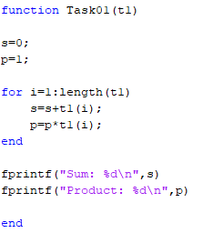

**Output:**



### Exercise 2

Given the array:

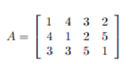

use MATLAB statements to find:

1. The number of rows and columns in A

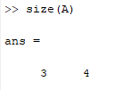

1. The maximum and minimum element values in A

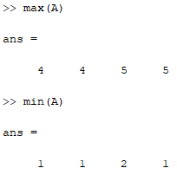

1. The maximum and minimum element values in each row of A

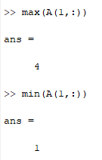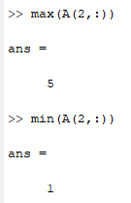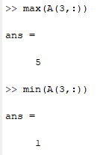

1. The average value in each column

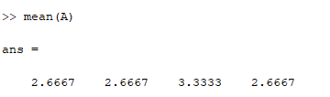

1. The average of all element values

